AI-Lab 03 Tasks Submission

Name: Yash Raj
Roll Number: 24k-0737

Task 01:
class Environment:
def __init__(self, rooms):
self.rooms = rooms

def goal_achieved(self):
return all(r == "Clean" for r in self.rooms)

def show(self):
print(self.rooms)

class Agent:
def __init__(self, env):
self.env = env
self.pos = 0
self.goal = "Clean all rooms"

def run(self):
step = 1
while not self.env.goal_achieved():
print("Step:", step)
print("Percept:", (self.pos, self.env.rooms[self.pos]))
print("Goal:", self.goal)

if self.env.rooms[self.pos] == "Dirty":
action = "Clean"
self.env.rooms[self.pos] = "Clean"
else:
if self.pos < len(self.env.rooms) - 1:
action = "Move Right"
self.pos += 1
else:
action = "Move Left"
self.pos -= 1

print("Action:", action)
self.env.show()
print()
step += 1

rooms = ["Dirty", "Clean", "Dirty"]
env = Environment(rooms)
agent = Agent(env)
agent.run()

Output:
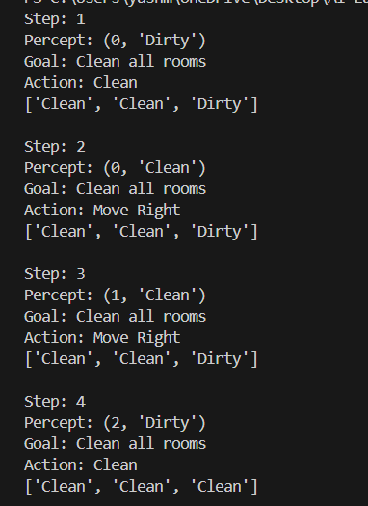

Task 02:
class Environment:
def __init__(self, rooms):
self.rooms = rooms

def goal_achieved(self):
return all(r == "Clean" for r in self.rooms)

def show(self):
print(self.rooms)

class Agent:
def __init__(self, env):
self.env = env
self.pos = 0
self.total_utility = 0

def utility(self, action):
if action == "Clean" and self.env.rooms[self.pos] == "Dirty":
return 10
if action == "Move":
return -1
return -5

def run(self):
step = 1
while not self.env.goal_achieved():
actions = ["Clean", "Move", "Do Nothing"]
utilities = {a: self.utility(a) for a in actions}
best_action = max(utilities, key=utilities.get)

print("Step:", step)
print("Action:", best_action)
print("Utility:", utilities[best_action])

self.total_utility += utilities[best_action]

if best_action == "Clean":
self.env.rooms[self.pos] = "Clean"
elif best_action == "Move":
self.pos = min(self.pos + 1, len(self.env.rooms) - 1)

print("Total Utility:", self.total_utility)
self.env.show()
print()
step += 1

rooms = ["Dirty", "Dirty", "Clean"]
env = Environment(rooms)
agent = Agent(env)
agent.run()

Output:
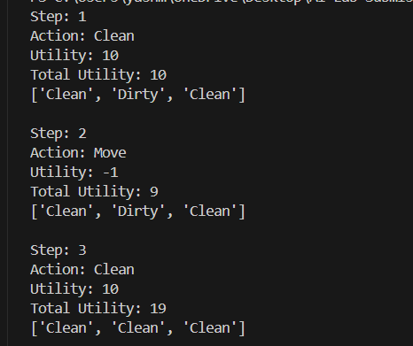

Task 03:
class Environment:
def __init__(self, rooms):
self.rooms = rooms

def goal_achieved(self):
return all(r == "Clean" for r in self.rooms)

class Agent:
def __init__(self, env):
self.env = env
self.pos = 0
self.q_table = {}
self.actions = ["Clean", "Move"]

def state(self):
return (self.pos, tuple(self.env.rooms))

def choose_action(self, state):
# Choose Clean if dirty, otherwise Move
if self.env.rooms[self.pos] == "Dirty":
return "Clean"
else:
return "Move"

def update_q(self, state, action, reward, next_state):
self.q_table.setdefault(state, {})
self.q_table[state][action] = reward

def run(self):
self.pos = 0
self.env.rooms = ["Dirty", "Dirty", "Dirty"]

while not self.env.goal_achieved():
state = self.state()
action = self.choose_action(state)

if action == "Clean":
self.env.rooms[self.pos] = "Clean"
reward = 10
else:
self.pos = min(self.pos + 1, len(self.env.rooms) - 1)
reward = -1

next_state = self.state()
self.update_q(state, action, reward, next_state)

print("Final Q-Table:")
for s, a in self.q_table.items():
print(s, a)

env = Environment(["Dirty", "Dirty", "Dirty"])
agent = Agent(env)
agent.run()

Output:
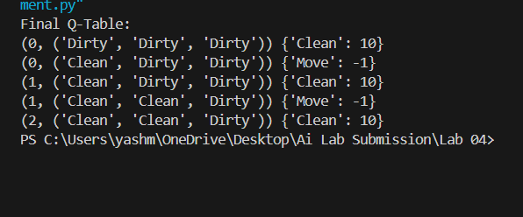

Task 04:
class Environment:
def __init__(self, rooms):
self.rooms = rooms.copy()

def goal_achieved(self):
return all(r == "Clean" for r in self.rooms)

def show(self):
print(self.rooms)

class ReflexAgent:
def __init__(self, env):
self.env = env
self.pos = 0
self.steps = 0

def run(self):
while not self.env.goal_achieved():
self.steps += 1
if self.env.rooms[self.pos] == "Dirty":
self.env.rooms[self.pos] = "Clean"
else:
self.pos = min(self.pos + 1, len(self.env.rooms) - 1)
return self.steps

class LearningAgent:
def __init__(self, env):
self.env = env
self.pos = 0
self.q_table = {}

def choose_action(self):
if self.env.rooms[self.pos] == "Dirty":
return "Clean"
else:
return "Move"

def run(self):
steps = 0
while not self.env.goal_achieved():
steps += 1
action = self.choose_action()
state = (self.pos, tuple(self.env.rooms))
if action == "Clean":
self.env.rooms[self.pos] = "Clean"
reward = 10
else:
self.pos = min(self.pos + 1, len(self.env.rooms) - 1)
reward = -1
self.q_table.setdefault(state, {})[action] = reward
return steps

rooms = ["Dirty", "Dirty", "Dirty"]

env1 = Environment(rooms)
reflex = ReflexAgent(env1)
reflex_steps = reflex.run()
print("Reflex Agent Steps:", reflex_steps)

env2 = Environment(rooms)
learning = LearningAgent(env2)
learning_steps = learning.run()
print("Learning Agent Steps:", learning_steps)

print("Learning Agent Q-Table:")
for s, a in learning.q_table.items():
print(s, a)
Output:
